Contents

1 Background 3

2 HydroDyn Module 4

2.1 Input data 5

2.1.1 Joints 5

2.1.2 Members and member property sets 6

2.1.3 Marine growth 6

2.1.4 Added mass coefficients and drag coefficients 7

2.2 Reconstruct members 8

2.2.1 Member reconstruction according to marine growth 9

2.2.2 Create super members 10

2.2.3 Set markers 13

2.3 Load calculation in each time step 15

3 Members in global coordinate system 16

3.1 Regular member local coordinate system 16

3.2 Transfer regular member from local coordinate system to global coordinate system 16

3.3 Super member in master local coordinate system 17

3.4 Super member in global coordinate system 18

4 Create super member: boundary and new nodes 20

4.1 The coordinate of the characteristic points 20

4.2 Point A and B 21

4.3 The distance from a point to the center plane 21

4.4 Create new nodes at the super member boundary 21

5 Super member volume 22

6 Load calculation 23

6.1 Normal conditions 23

6.1.1 Interior marker 23

6.1.2 End marker 25

6.1.3 Super member marker 26

6.2 Marine growth effect 27

6.3 Flooded members 28

Reference 29

# Background

FAST is an aero-hydro-servo-elastic tool widely used for analyzing onshore and offshore wind turbines. Modifications are made to FAST to enable the examination of offshore wind turbines with fixed-bottom multi-member foundations (which are commonly used in transitional-depth waters). Previously, FAST only had the capability of examining floating wind turbines and wind turbines with monopile foundations offshore. Adding this new capability to FAST will allow this tool to analyze a new class of substructures that hold a vital role in the offshore wind support-structure portfolio, such as offshore tripod and jacket support structures.

Previously, Morison and hydrodynamic loads are examined only on vertical and straight cylinder members. The multimember support structures, such as tripod and jacket foundations, include not only straight vertical members, but also tapered and inclined cylinder members, which make the analysis much more complicated than before. The intersecting members at the joint make the modeling even more complicated. The current analysis is to examine how the fluid affects the complicated structure that consists of multi-members, model the Morison loads and buoyancy loads on inclined and tapered members, and the loads at the joint considering the intersection of members.

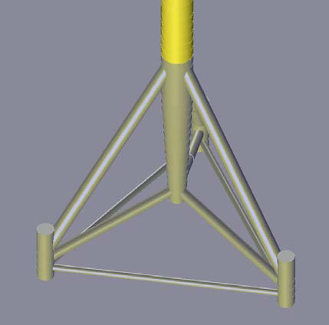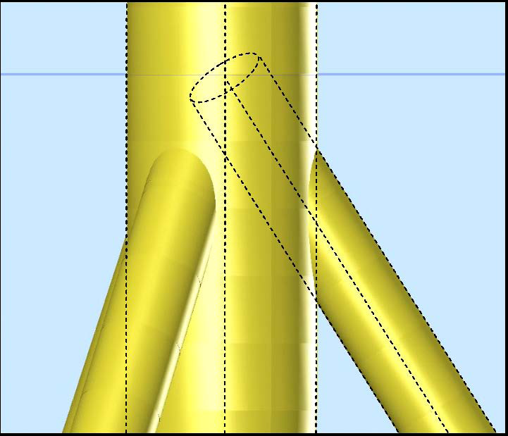

Figure 1

For the tripod foundation and jacket foundation, there are a number of issues caused by the overlapping of members at joints. Figure 1 shows an example of the overlapping region close to the mean sea level in the tripod. For the large diameter members of the tripod configuration, significant surface areas and volumes are duplicated with smaller member, distorting the overall level of wave and buoyancy loading. The intersecting members will also have an influence on the mass of the tripod. Therefore it is important to find the overlap volume for intersecting members.

We present a method to accurately calculate the actual displaced volumes, which takes into account the overlapping parts at the member joints. At the joints, we will create at super member according to the user option and some conditions. The exact volume of the super member will be calculated. The buoyancy and hydrodynamic loads on tapered and tilted members of the support structure are also considered in the method.

Marine growth and member flooding are common to offshore structures and may have significant effect on the loads and dynamic behaviors of the structure. Therefore, modeling marine growth and flooded members are incorporated in the HydroDyn module to understand those effects.

# HydroDyn Module

FAST is the structure analysis tool and HydroDyn is the hydrodynamic loading calculation module. At initialization, HydroDyn will read the input file, reconstruct members and set up markers, calculate buoyancy forces, marine growth, flooded forces and added mass. At each time step, HydroDyn will calculate the fluid-inertia forces, viscous drag forces, and dynamic pressure forces at each marker. A marker is defined here as a node with a body fixed coordinate system attached to it.

Future work for HydroDyn module :

* The deflection of the structure, except for the structural velocity and acceleration in Morison’s equation
* Tangential drag on the cylinder
* Added mass and fluid inertia force at the end marker
* An option at the joint that the super member is created by extending the member surface at the joint to form a closed surface
* An option at the joint that the user can input the joint volume and the boundary points of the super member.
* The exact projected area ( in ) of the super member that is perpendicular to the wave direction

We only consider a structure consist of cylinder members.

HydroDyn

FAST

Initialization

Time Stepping

Termination

Termination

Read Input

Reconstruct

members

Set up markers

Load calculation

Figure 2

## Input data

### Joints

The input data will have information on the joints, members, member properties and marine growth. In the input file, an option for each joint will be provided, the options being 0, 1, 2 and 3.

For option 0, no calculation is performed at the joint, i.e. no marker is set at such a joint. If the user chooses the option 1/default at the joint, then we don’t calculate overlapping at the joint; for option 2, we will extend the member surfaces and use a method to extend the member surfaces and calculate the approximated overlapped volume and surface areas; for option 3, we’ll calculate the exact overlapped volume at the joint, neglecting secondary overlapping between submembers. Because option 3 requires the members at the joint to satisfy certain conditions, if the conditions are not satisfied, then we’ll overide the user defined option and use the Default option. Option 2 is presently unavailable. When a WAMIT member connects to a Morison member, option 1/default option is used at the joint.

Table 1: Joint information

|  |  |  |  |  |
| --- | --- | --- | --- | --- |
| JointID | JointXi | JointYi | JointZi | JointMod |
| 1 | 0.0 | 0.0 | 0.0 | 0 |
| 2 | 1.0 | 0.0 | 0.0 | 1 |
| 3 | 0.0 | 1.0 | 1.0 | 2 |

Table 2: Options at joints

|  |  |
| --- | --- |
| Options for each joint | |
| default | Do not consider overlapping at the joint (Free end marker at the joint). |
| 0 | Do not calculate loads at the joint (no marker at the joint). |
| 1 | Do not consider overlapping at the joint (Free end marker at the joint). |
| 2 | Consider modified overlap at the joint (Currently unavailable). |
| 3 | Consider full overlap at the joint, no secondary overlapping. |

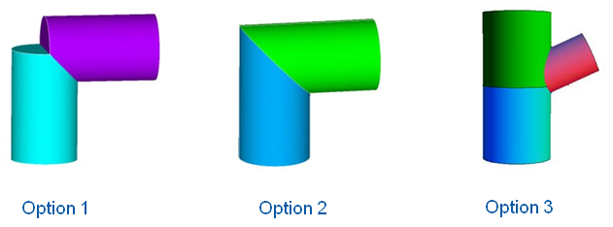

Figure 3: Options at joints

### Members and member property sets

For the member information, we provide joints in each member, the property set the member belongs to and an input for the division size, so the user can define how the member will be discretized in the calculation. After discretization of the member, we will define some markers in each member, and the forces and moments are calculated at these markers.

Table 3: Member information

|  |  |  |  |  |
| --- | --- | --- | --- | --- |
| MemberID | Joint1 | Joint2 | PropertySet | DivisionSize |
|
| 1 | 1 | 2 | 1 | 0.1 |

The property set of the member has the information of the cylinder outside diameters and thickness at each member joint, the flag of flooded member or not, the internal fluid density if the member is flooded and a WAMIT member flag. If the WAMITFlag is true, then only viscous drag, marine growth and flooded forces are calculated at the member markers. D1, t1 and D2, t2 are corresponding to Joint1 and Joint2 respectively. For the markers in between joints, the diameters and thickness are linearly interpolated according to the end joints properties.

Table 4: Member properties

|  |  |  |  |  |  |  |
| --- | --- | --- | --- | --- | --- | --- |
| PropSetID | D1(m) | D2(m) | t1(m) | t2(m) | CoeffOpt | WAMITFlag |
| 1 | 5.687 | 5.673 | 0.031482 | 0.030907 | 1 | TRUE |
| 2 | 5.687 | 5.673 | 0.031482 | 0.030907 | 2 | FALSE |
| 3 | 5.687 | 5.673 | 0.031482 | 0.030907 | 3 | FALSE |

### Flooding/Ballasting

User needs to provide a table for members that are flooded or ballasted. Since there are similarities for ballasting and flooding, so we combine flooding and ballasting together as filled members. Each filled group should share the same free surface location, which means the members in the group are connected without caps, so the filled water reaches to the equilibrium state without external pressure. The FilledDensity is density of the filled fluid, which is default as 1025 .

Table 5: Filled groups

|  |  |  |  |  |
| --- | --- | --- | --- | --- |
| FilledGroupID | FreeSurfaceLocation | NumOfMembers | ListOfMembers | FilledDensity |
| 1 | 0.0 | 2 | 1,2 |  |
| 2 | -10.0 | 3 | 3,4,5 | 5000 |

### Marine growth

Marine growth is taken into account by increasing the outer diameter of the structural member in the calculation of the hydrodynamic wave loads and by adding an added mass and a weight associated with the growth. The thickness of the marine growth depends on the depth below sea level. Table 6: Marine Growth shows an example of marine growth thickness and density with depth of water. The adjusted thickness and density of each member is linearly interpolated according to Table 6.

Table 6: Marine Growth

|  |  |  |
| --- | --- | --- |
| Table size: | 9 | |
| Depth (m) | MGThickness (mm) | MGDensity (kg/m^3) |
|
| 2.0 | 100.0 | 1100.0 |
| 0.0 | 100.0 | 1100.0 |
| -2.0 | 100.0 | 1100.0 |
| -10.0 | 100.0 | 1100.0 |
| -20.0 | 100.0 | 1100.0 |
| -30.0 | 100.0 | 1100.0 |
| -40.0 | 100.0 | 1100.0 |
| -45.0 | 50.0 | 1100.0 |
| -50.0 | 50.0 | 1100.0 |

### Added mass coefficients and drag coefficients

There are three options for the added mass and drag coefficients inputs, which are user option 1, 2 and user option 3. Default coefficients are used for option 1. The default coefficients [1] are listed in Table 7: User option 1 - Default coefficients. The coefficients with marine growth will be taking into account according to the depth-dependent marine growth user provided as in Table 6. For user option 2, the user can provide added mass coefficients and drag coefficients in terms of depth such as Table 8. For user option 3, the user can provide added mass coefficients and drag coefficients for each member as Table 9. In Table 9, CA1, CD1, and CA2, CD2 are corresponding to Joint1 and Joint2 respectively. If not all the members are provided, then default CA and CD will be used. For user defined options, the added mass and drag coefficient for each marker are linearly interpolated according to the table provided by the user.

Table 7: User option 1 - Default coefficients

|  |  |  |
| --- | --- | --- |
| Cd | 0.65 | smooth surface without marine growth |
| 1.05 | rough with marine growth |
| Ca | 0.6 | smooth surface without marine growth |
| 1.0 | rough with marine growth |

Table 8: User option 2 – Depth dependent added mass and Drag coefficients

|  |  |  |
| --- | --- | --- |
| Table size: | 3 | |
| Depth(m) | Ca | Cd |
| 2.0 | 0.7 | 0.8 |
| -20.0 | 1.0 | 1.0 |
| -50.0 | 1.0 | 1.0 |

Table 9: User option 3 – Member added mass and Drag coefficients

|  |  |  |  |  |
| --- | --- | --- | --- | --- |
| PropSetID | CA1 | CA2 | CD1 | CD2 |
| 3 | 0.7 | 1.0 | 0.8 | 1.0 |

## Reconstruct members

In the initialization step, we need to reconstruct members if the marine growth is taking into account or option 3 is selected at the joints. Marine growth is very common for offshore structures. In order to take into account the marine growth effect, members need to be reconstructed at the border of the marine growth region, so that we can calculate the marine growth weight and the forces due to marine growth. When option 3 is selected and the joint conditions are satisfied, we need to create a super member at such a joint, therefore changing the original member information. During the process of reconstruction, new nodes and members may be created. The original node, member and member property lists need to be updated.

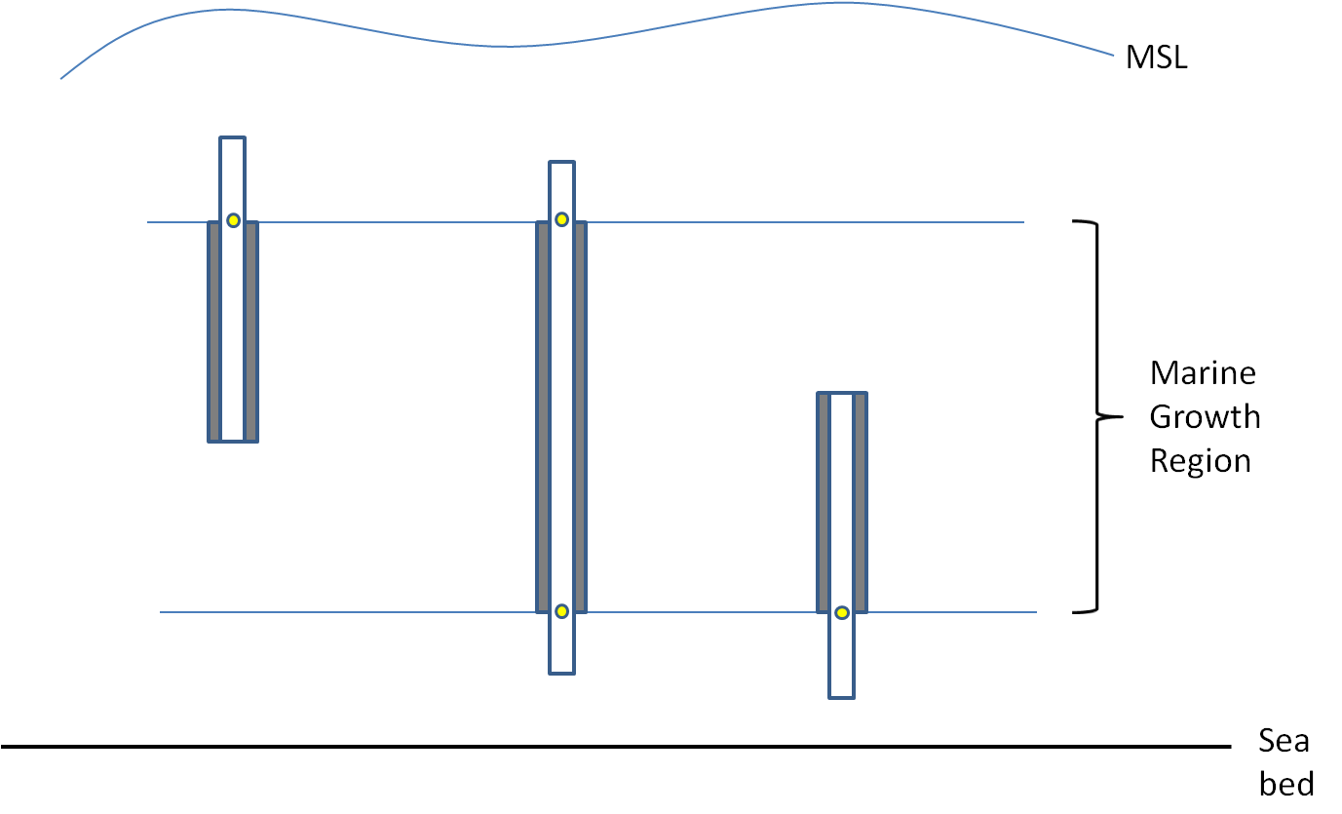

Figure 4



Figure 5

### Member reconstruction according to marine growth

Marine growth happens if members are positioned in certain depth of the water. We need every member to be completely outside of the marine growth region or completely inside the marine growth region. Therefore, if the member is partially inside/outside the marine growth region, we will separate the member into two or three members according to the position of the member, as illustrated in Figure 4. New nodes and members are created. New members will have linearly interpolated diameters and thickness, and other properties are inherited from the original members. Each member will be assigned a marine growth flag.

### Create super members

Yes

Next joint

*

Find the connectivity at the joint

*

No

*

*

*

*

*

No

Finish reconstruct

member module

Yes

Find boundary of each member at the joint

Create new nodes, coordinates

Create a super member at the joint

Flag master & slave members

Update node, member lists and properties

Check member alignment (calculate angles

between connected members)

For each joint do

Update regular member node

Create super members

* >=3 members at the joint

* 180

°

alignment

with R

1

=R

2

* Option = '2', calculate overlap

Finish

all the

joints ?

Figure 6: Reconstruct members flow chart

#### Connectivity

At the first step of construct super members, we need to find out the connectivity at the joint, which is how many members are connected at each joint, and what are the angles between connected members.

If joint option 3 is specified, we are going to create the super member if there are more than three members connected at the joint and there is at least one 180 angle between connected members. Also, the members aligned in the 180 degrees must have the same diameter.

For the jacket structure, there are several types of connections at one joint. They are 1, 2, 4, 6 members at one joint. The ones where we are going to create a super member are the joints with four or six members connected at the joint. They all satisfy the required conditions.

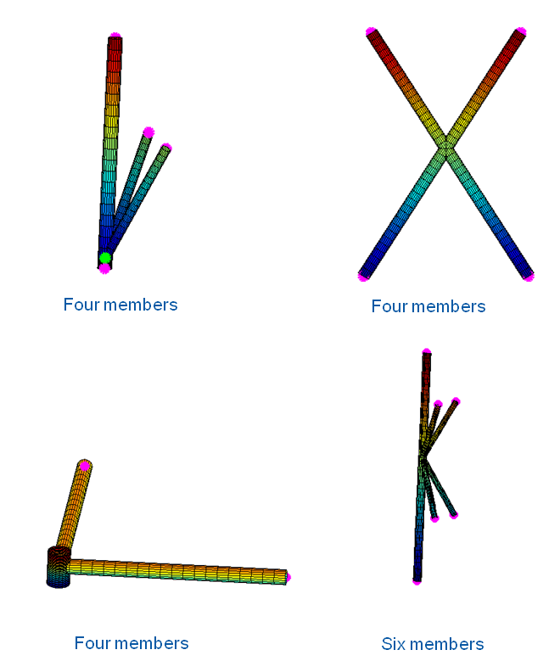

Figure 7: Types of joints of Jacket structure

For the tripod structure, the connection types are 1, 2, 3, 4, and 5, members at one joint. The ones where we are going to create a super member are the joints with 3, 4, 5 members connected at the joint. They all satisfy the required conditions.

For the members at joints that do not satisfy the conditions, we keep the members as they are, and we call them regular members in order to be distinguished from the super member.

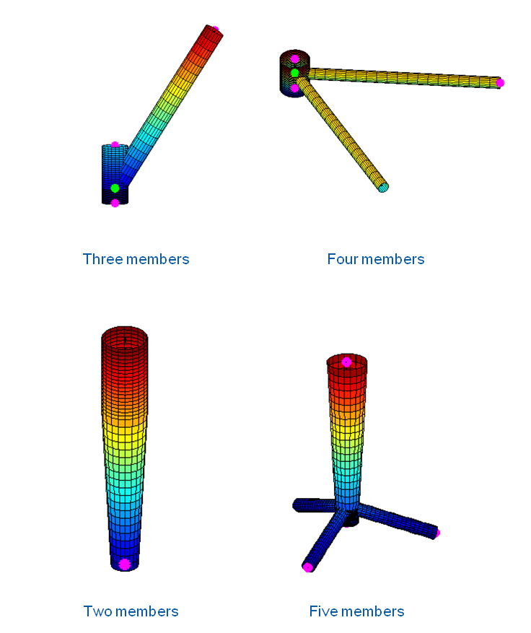

Figure 8: Types of joints of Tripod structure

#### Create super member

For the members at the joint that satisfy the conditions, the idea is to find the boundary plane to bound the intersecting region. And the bounded region will be created as a super member.

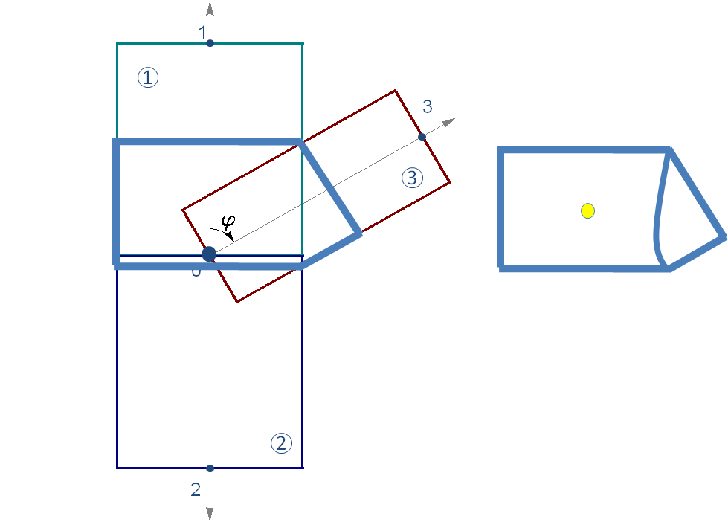

Figure 9

Figure 9 shows three members at one joint. According to the member alignment (members 1 and 2 are aligned in 180 degrees, and have the same diameter), member 3 intersects with member 1 at an angle . So we denote member 1 and 2 as master members, and member 3 as a slave member. The region that encloses the intersecting part is defined as a super member. The detailed calculation to create the super member is discussed in Section 4.

### Set markers

Next member

No

Yes

Finish marker and

integral module

Set Markers and Integrals

Discretize member

Define end or

interior markers

Regular member

Super member

Calculate the volume of the

super member

Define super member marker

For each member do

member type?

Finish all

members?

Figure 10

After reconstructing members, all members can be divided into two types. One type is the regular member, which are cylinders, either straight or tapered. The other type is the super member, which are combination of intersecting cylinders.

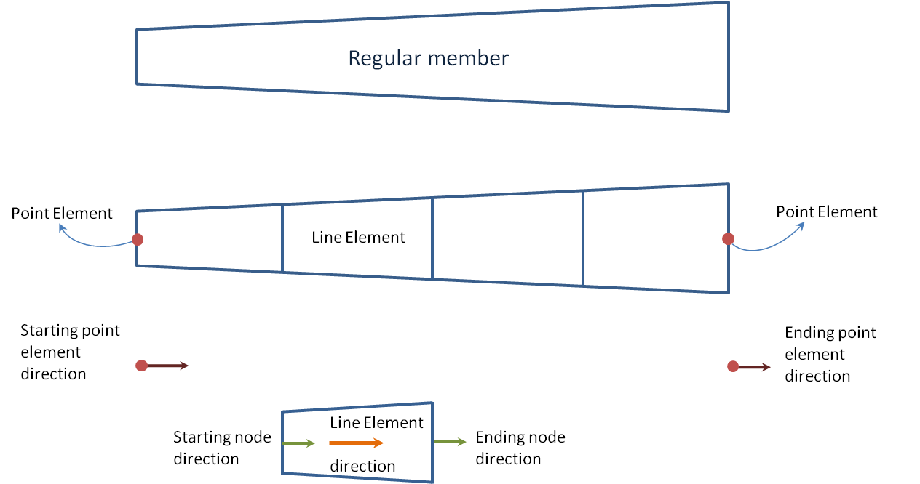

Figure 11: Regular member elements

The regular members are discretized into various numbers of elements according to the division size defined by the user, and two point elements are defined at the end plane of the member. Figure 11 shows the point elements and line elements of the member. If the member is not connected to a super member, then we set an end point element at each end of the member, which are shown as red dots in the figure. If the member is connected to a super member, then we set no end point element at the connecting end of this member. Each element will have the information such as the position, the direction cosines, the diameter and the tapered ratio, and etc.

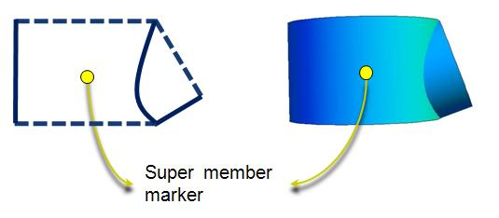

Figure 12: Super member marker

The super member marker is set at the center of the master member. The forces are calculated at the super member marker. For the super member, we will calculate the volume of the super member for the Morison calculation in this initialization part, since the volume of the super member is not changing at each time step. The calculation of super member volume is discussed in Section 5.

When we finish all the members, all the markers are set, and the initialization part is finished.

## Load calculation in each time step

Figure 13

Next Marker

Yes

No

No

Interior Marker

Super Marker

Yes

Finish load

calculation module

* Calculate distributed Morison forces

* Calculate distributed buoyancy forces

and moments

* Calculate point buoyancy

forces and moments

* Calculate point Morison drag

at the marker

* Calculate point buoyancy

forces

* Calculate point Morison

forces at the marker

Load Calculation

End Marker

For each marker do

marker type?

Marker above free

surface or below sea

bed?

Finish all

markers?

In each time step, hydrodynamic loads are calculated at the markers. If the marker is positioned above the free water surface or below seabed, then we don’t calculate the hydrodynamic loads, flooded loading, and hydrodynamic loads due to marine growth at the marker. Otherwise for different types of markers, we do different calculations.

For the regular member, we have defined the interior markers and end markers. For the interior markers, we calculate distributed buoyancy forces and moments, and distributed Morison loads at the interior marker. At the end marker, we calculate concentrated buoyancy forces and moments, and also Morison drag force at the cross-section.

For the super member, we will calculate concentrated Morison loads at the joint. Also the concentrated buoyancy forces are calculated with respect to the center of the master member.

# Members in global coordinate system

* Global coordinate system: . The origin is set at the mean sea level, the center of the structure, with axis positive upward. The positive axis is along the nominal (zero-degree) wave propagation direction.

## Regular member local coordinate system

The regular member local coordinate system is set as follows:

* Member local coordinate system: 
* The origin is set at the center of the cylinder.
* The local axis is along the cylinder axis, directed from the start point to the end point. The start point is defined as the end point that has a lower coordinate value. If the two end points have the same coordinate value, then the one that has the lower coordinate value is the start point. If the two end points have the same and coordinate value, then the one that has the lower coordinate value is the start point.
* The local axis is parallel to the global plane, positive along the nominal wave propagation direction. If the cylinder’s axis is along the global direction, then the local axis is parallel to the plane, and positive along the negative global direction.
* The local axis follows right hand rule.

The super member local coordinate is set as the master local coordinate. The joint is the start point for all the members at the joint.

## Transfer regular member from local coordinate system to global coordinate system

For regular members, the cylinder expression in global coordinate system can be found as follows:



where  and  are the start and end joints of the member in global coordinate system of the member, and  is the direction cosine matrix of the member axis and can be obtained as follows:



where  and . When  and , the  matrix can be found as follows:



## Super member in master local coordinate system



Figure 14

A super member will include a master member, a secondary master member and at least one slave member. For the master cylinder (green in Figure 14) in it’s local coordinate system , the origin is set at the top of the cylinder. The axis (cylinder axis) is directed from the start point to the end, with the joint being the start point. The local axis is in the master cylinder top plane and in the direction that parallel to the global plane. The blue Cylinder is considered as the secondary master. The master cylinder with free parameters  in it’s local coordinate system can be written as:



The slave cylinder with free parameters in the master’s local coordinate system can be found as:



where angle  is the intersecting angle between master and slave members. The surface of the master cylinder intersected by the slave cylinder with free parameters  in the master’s local coordinate can be found as:



## Super member in global coordinate system

The master member of the super member in global coordinate system can be obtained using equation . The slave cylinder axis needs to lie in the x-z plane of local master coordinate system for an easier calculation of the intersecting points. Therefore, the rotation of the slave cylinder needs an angle , which is the angle between master axis and slave cylinder axis projected on the master top plane.

Angle is illustrated in Figure 15. Cylinders in cyan are rotated together using the master transformation matrix. The slave cylinder in pink is at the real location in the space. Axis  projected on the master top plane is aligned with master  with 180 degrees.  is the angle between  and projection of . After being rotated together with the master cylinder, the slave cylinder in cyan needs to be rotated with respect to  in an angle  to reach its actual location.



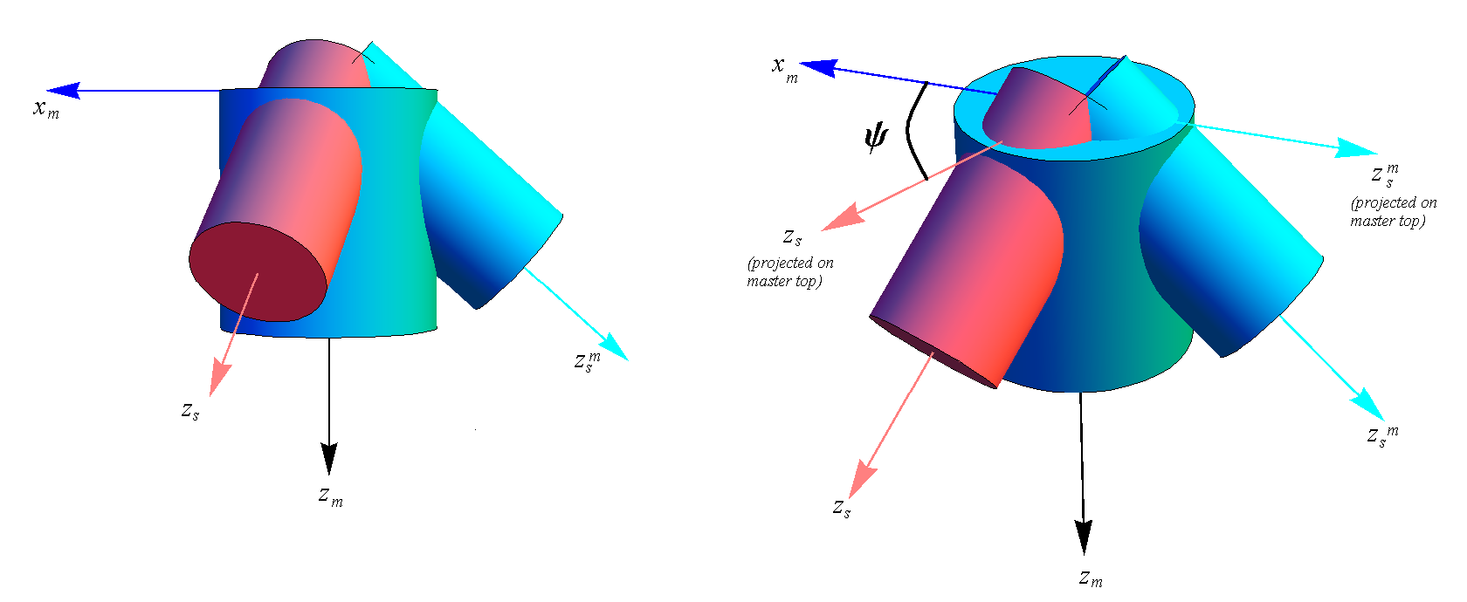

Figure 15: Angle

The slave member and the common surface can be transformed from master local coordinate system to global coordinate system as follows:



where  is the direction cosine matrix of the master cylinder,  is the length of the master cylinder,  can be calculated as follows:



The angle  can be calculated as follows:





where  is the unit direction vector of the slave axis projection on the master top plane,  are the components of the master direction cosine matrix,  and  are the global  coordinate of master end node and slave end node respectively. The unit direction vector  can be calculated as follows:



where  is the identity matrix, and  are the components of the slave member direction cosine matrix.

# Create super member: boundary and new nodes

## The coordinate of the characteristic points

If the members at the joints satisfy super member conditions, we will check the intersecting angle of the members at the joint, so that the slave cylinder and the master cylinder are intersecting in a way that the common volume is bounded by complete cross-section planes and cylindrical surfaces of the slave and master cylinders. In other words, the slave cylinder cannot intersect with the master cylinder at the end planes, which pass through points 1 and 2. Then we are going to find some characteristic points, A, and B (Figure 16) on the slave member. Points A and B are top and bottom points on surface where the slave member intersects with the master member. The super member boundaries are the surfaces enclosed by AA’B’BA’’.

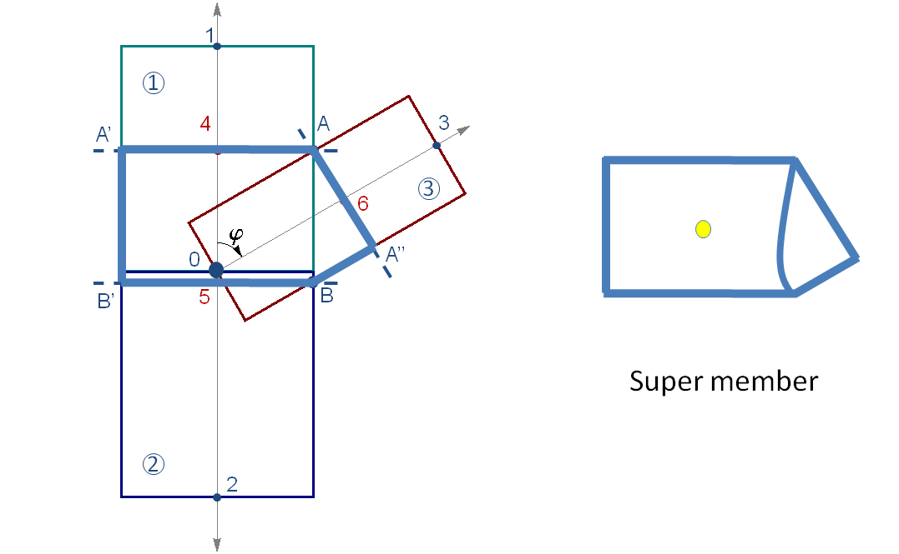

Figure 16

## Point A and B

Point A and B can be found by setting ,  and ,  in equation respectively, and then transform to the global coordinate system.

## The distance from a point to the center plane

In each member orientation, we want to find the point which has the largest distance from the member start plane. For the example shown in Figure 16, in member 1 orientation, A has the largest distance from the member 1 start plane. In member 3 orientation, point A is the farthest point from the start plane of member 3. In member 2 direction, point B is the farthest point from the start plane of member 2. The distance from an arbitrary point to the center plane can be calculated as follows.

The center plane goes through point 0, and has the out normal of . In the member 1 direction, the center plane out normal is the same as the vector . Then the distance between an arbitrary point = and the center plane is:



If , then the point is on the positive side of the plane.

If , then the point is on the negative side of the plane.

If , then the point is on the center plane.

 is magnitude of the distance between point  and the plane.

## Create new nodes at the super member boundary

In every member direction, we can create a plane that goes through the characteristic point and perpendicular to the axis of the member. This plane is the boundary plane for the super member at the corresponding member direction. This plane intersects with member axis at a new point. We make this new point as the new start point for the regular member and the end point of one direction of the super member. The new point can be found as follows:



where  is the joint coordinate,  is the member direction vector, and  is the characteristic point in the corresponding member direction.

Now we have all the boundary planes in all the member directions, we can create a super member. For the example shown in Figure 16, the super member is the region bounded by blue lines. The super member has 3 sub-members 1, 2, 3. Sub-member 1 has the start point 0 and end point 4. Sub-member 2 has the start point 0 and end point 6. Sub-member3 has the start point 0 and end point 5.

Figure 17 shows the example in 3D. The members before reconstruction, and the super member at the joint after reconstruction.

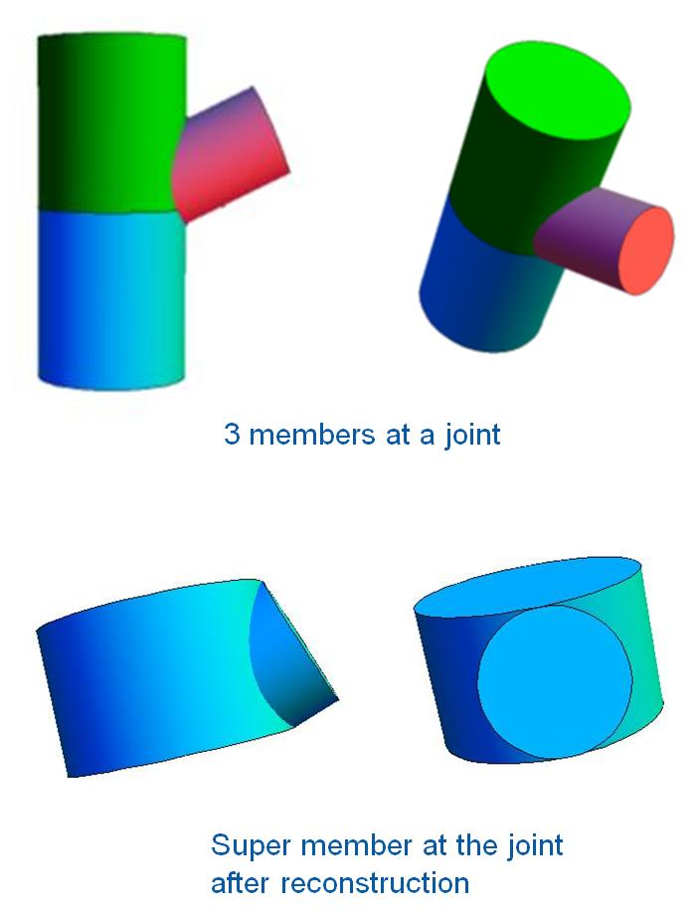

Figure 17

The reconstruction process will be performed at every joint that satisfies the conditions above. After we finish all the joints, we will have a new list of members and a new list of nodes. Some of the regular members will have new nodes. We will also have some new super members.

# Super member volume

Since the volume of the super member is not dependent on the coordinate system. Therefore, we can find the volume by geometry. The super member volume can be calculated as follows,



where and  is the radius and length of the master cylinder,  and  is the radius and length of the  slave cylinder, and  is the common volume between master and the  slave cylinder.  can be calculated as follows:



where  and  are the complete elliptic integrals of the first and the second kind respectively.

# Load calculation

At each marker, added mass and forces are calculated. Added mass and forces are split into several terms as follows:



where stands for inertia, stands for drag, stands for buoyancy, and stands for dynamic pressure.  is the added mass induced by the structure(including marine growth),  is the mass of marine growth and  is the mass of the filled fluid.

## Normal conditions

### Line Element

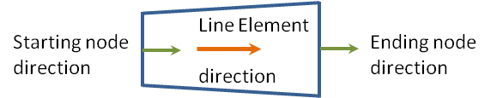

#### Morison equation (force per unit length)

The morison forces are calculated directly at the end plane of each line element.





where  is the axial unit vector in the global coordinate system at the marker. and  are the fluid and structure acceleration vector at the marker.  is the relative velocity vectors at the marker, where , and  are the fluid and structure velocity vectors at the marker.  is the marine growth thickness. is the outside radius of the cylinder and  is the inner radius of the cylinder where the flooded/ballasting fluid is filled. The forces are evaluated in the global coordinate system. The moments are neglected.

#### Distributed buoyancy forces and moments, dynamic pressure forces (per unit length)





 and  are evaluated in the global coordinate system.  and are the components in the direction cosine matrix for starting and ending plane of the element, respectively.  is the element direction cosine, pointing from starting point to ending point.  is the length of the element, and  is the volume of the element.

### End Point Element

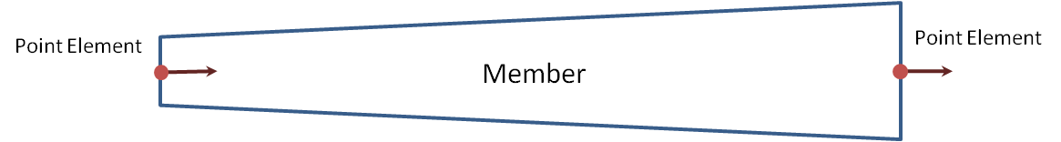

#### Forces on end point element (concentrated forces)



where  is the Morison drag,  is the point buoyancy force at the end surface .

* Morison drag:



* Point hydrostatic force and dynamic pressure forces:



 and  are evaluated in the global coordinate system. Super script and stand for start joint point and end joint point respectively.  are the components in the direction cosine matrix of the point element in equation or .

#### Added mass at end point element (heave plate effect)

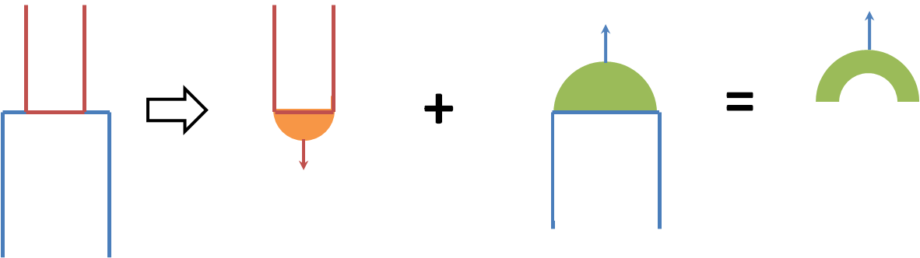

Figure 18: Added mass reference volume for heave plates

For every end point element, the direction cosine, , the diameter (outside  and inner ) and marine growth thickness  need to be recorded. For each point element location, the added mass force is calculated by summation of contributions from all point elements at the same location. Figure 18 illustrates of two heave plates joining at one point, where the added mass reference volumes are spheres. The added mass should be a positive value. Because we introduced a direction associated with the reference volume, therefore an absolute sign is used to make the resultant added mass positive.



where  is the added mass coefficient for three dimensional bodies in infinite fluid(far from boundaries). The default value of  is .

### Super member element

#### Morison equation (concentrated)





The calculation of volume used in equation can be found in Section 5.  is the unit direction vector of the master member. The area is an equivalent projection area perpendicular to the wave direction.  can be approximated from the total super member volume  and the length of the super member  as:



#### Point buoyancy forces (concentrated)

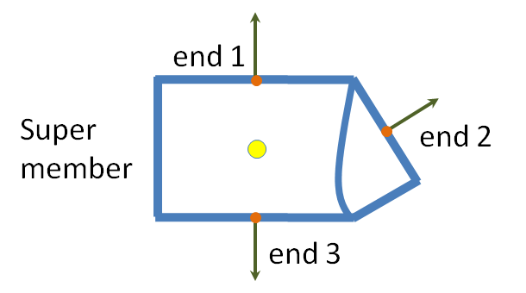

The buoyancy force is calculated by using the displaced super member volume times subtracting the contribution from the end cap surfaces as follows:



where  is the total volume of the super member,  is the point buoyancy forces at the end cap of the  member, and can be calculated using end point equation in , with subscript e. Dynamic pressure force is not calculated at the end caps.  and  are evaluated in the global coordinate system. The moment at the super member is not calculated.

## Marine growth effect

Marine growth is taking into account by increasing the outer diameter of the structural member in calculation of the hydrodynamic wave loads. The volume, cross-sectional areas used in the equations for calculating Morison loads and buoyancy loads will be adjusted to an effective diameter  including the marine growth thickness .

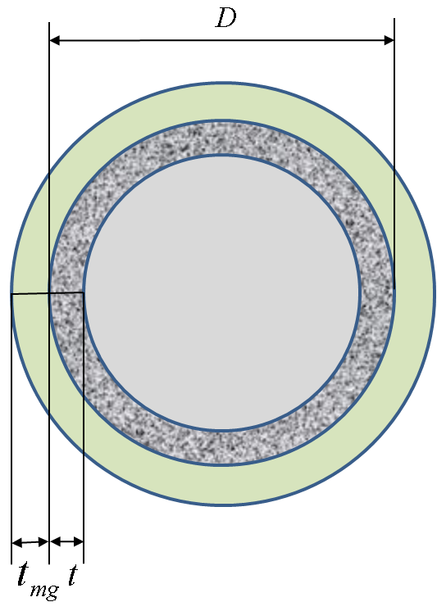

Figure 19



where  is the outer diameter of the cylinder structure, and  is the thickness of marine growth. In load calculation including marine growth effect, all the diameters  in equations ~ will be replaced by the effective diameter , and the inertia coefficient and the drag coefficient will be adjusted to take into account the marine growth effect, see Section 2.1.3.

The added mass force from marine growth is included in added mass forces terms for each case.

Added mass per unit length of the marine growth can be calculated as,



## Flooded members

In Figure 18, for a flooded member, the inner grey area will be filled with fluid. If the member has a nonzero FloodedNum, the flooded bouyancy force is calculated at associated markers, both regular and super member markers. The inner distributed hydrostatic forces due to flooding can be calculated using equation , and end cap forces can be calculated using equation , where  is specified free surface location,  is flooded volume, and radii are the inner radii of the member.





The mass per unit length of flooded fluid can be calculated as equation .



# Reference

1. API - Recommended Practice for Planning, Designing and Constructing Fixed Offshore Platforms—Working Stress Design, 2007